EXERCISE 4 SQL JOINS
Question 1 - Show every user who has a subscription. Match users to subscriptions.
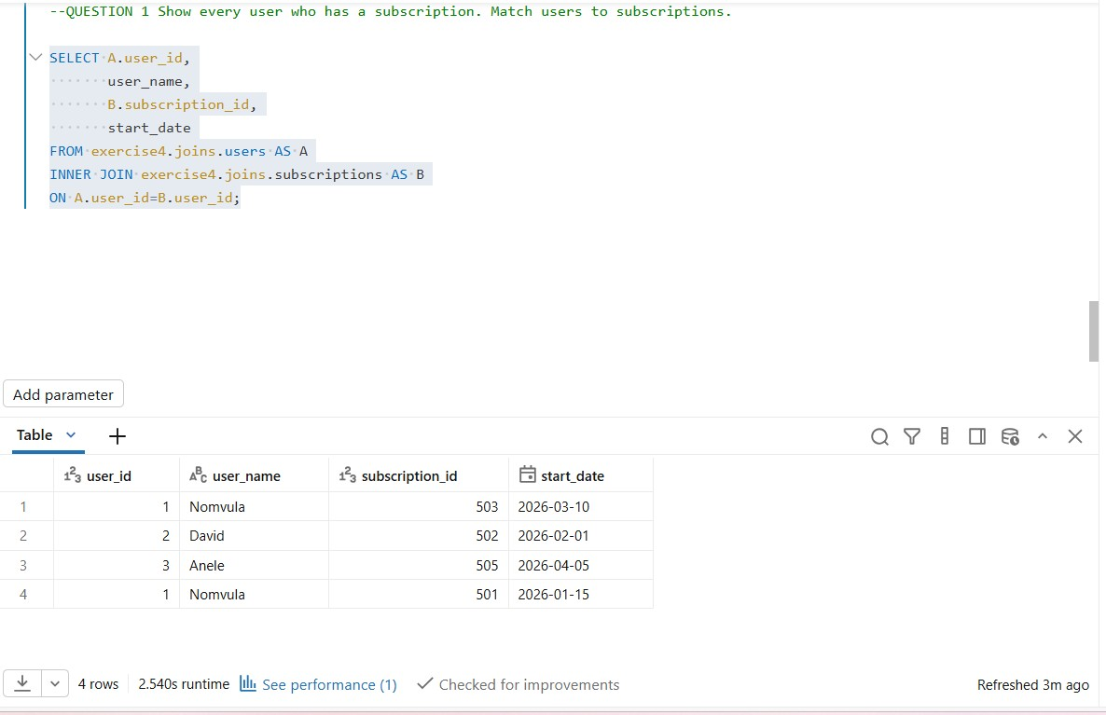

Show every subscription with its matching plan name and monthly
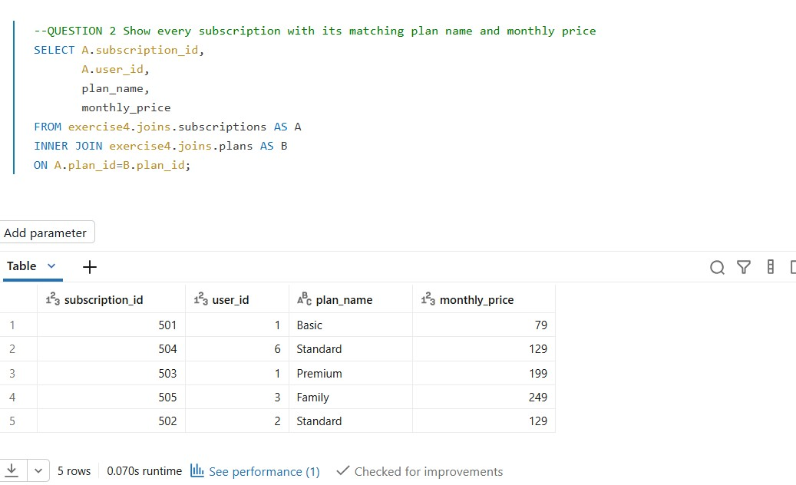

Show every viewing session that has a matching show. Include the show title and genre
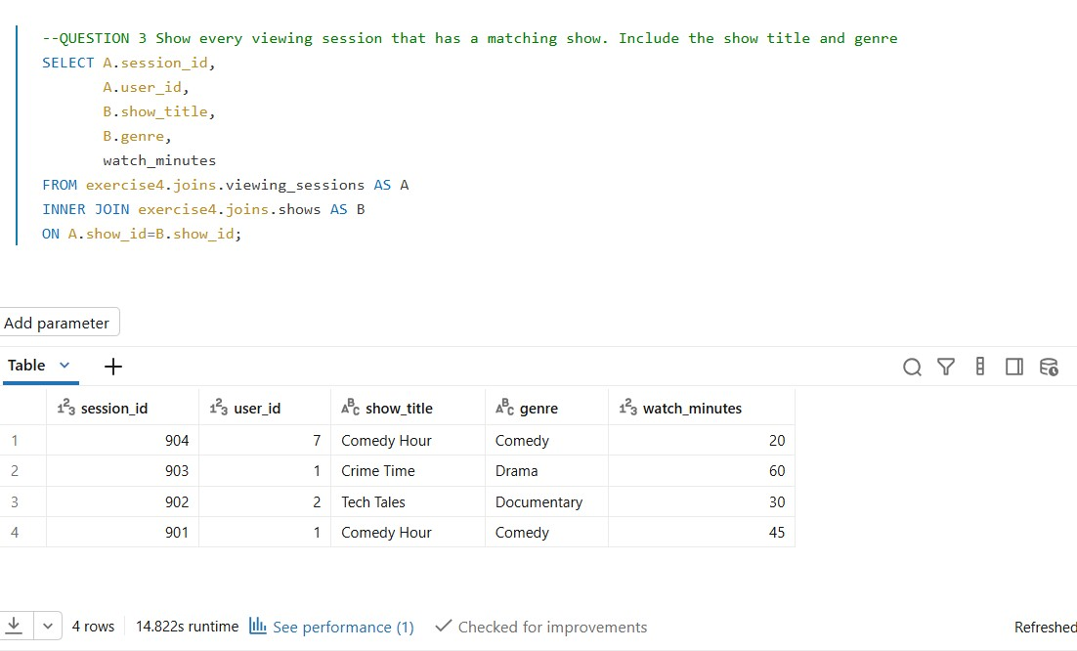

Show every viewing session with the user who watched it. Only show sessions with a matching user
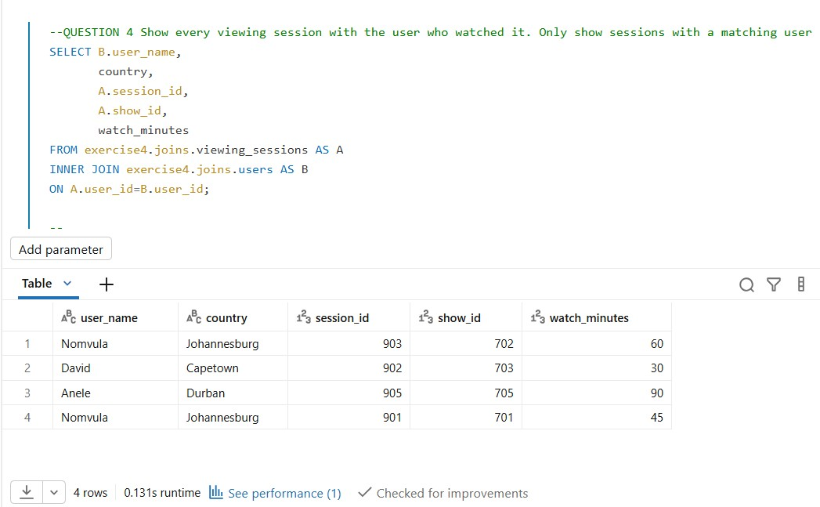

Show users along with their subscriptions, the plan name, and the price. Use only users who have both a subscription and a valid plan.
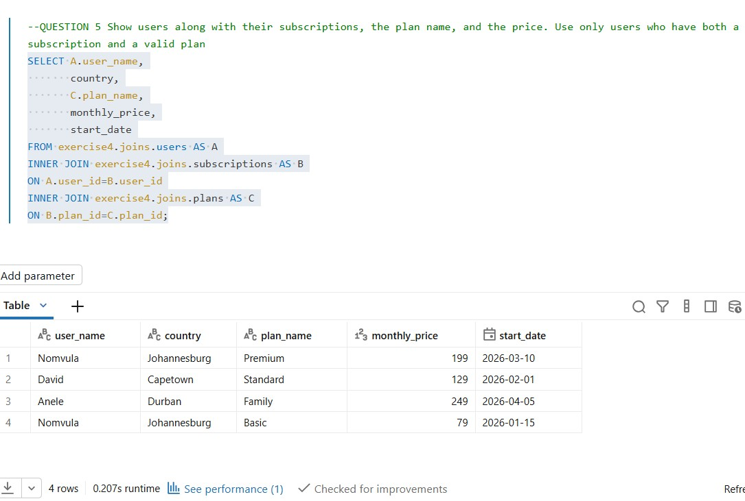

Show every user and any subscriptions they have. Users without subscriptions must still appear
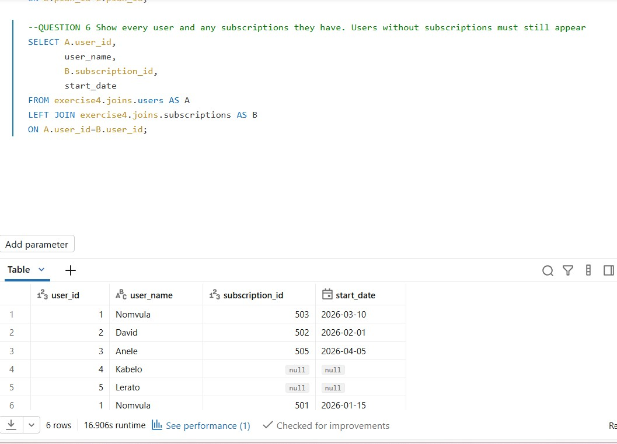

Show every plan and the subscriptions on it. Plans with no subscribers must still appear
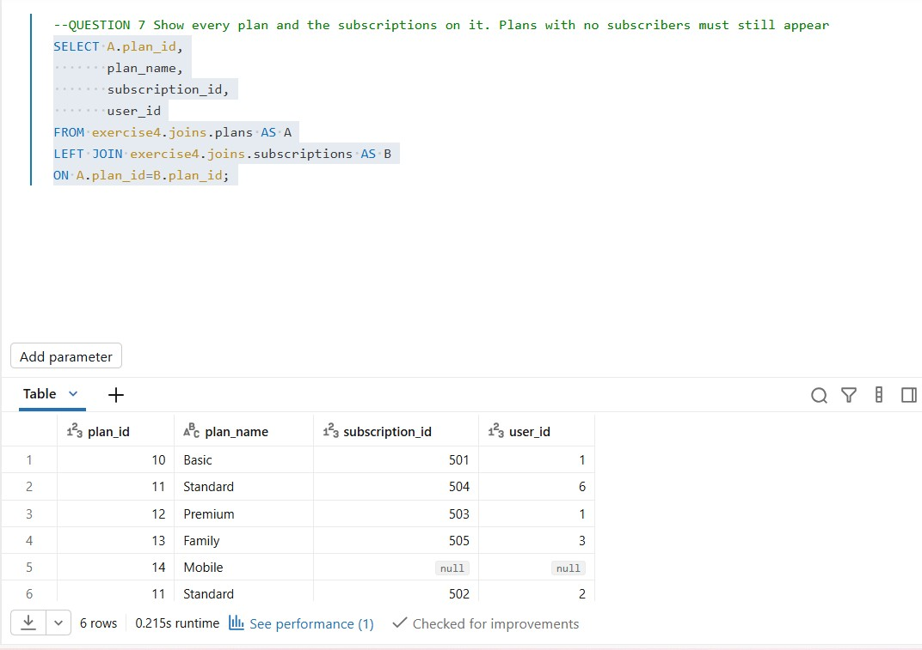

Show every show and any viewing sessions on it. Shows that were never watched must still appear
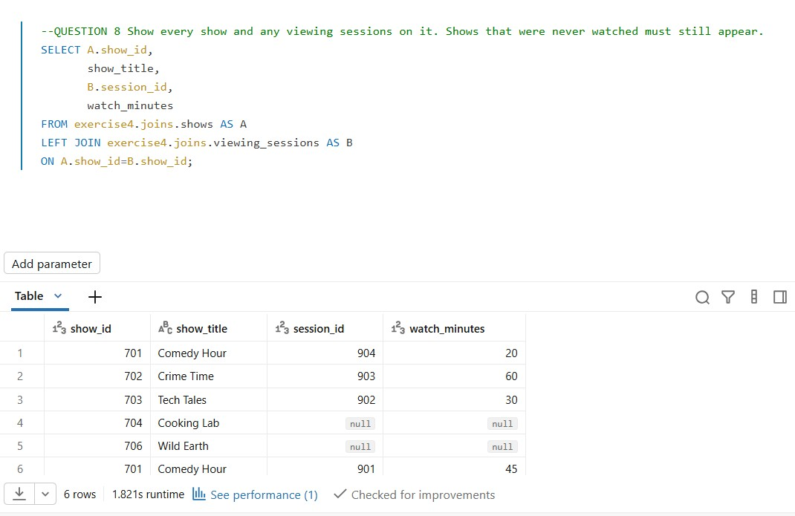

Show every viewing session and the user who watched it. Sessions referencing users that do not exist must still appear (with NULL user details).
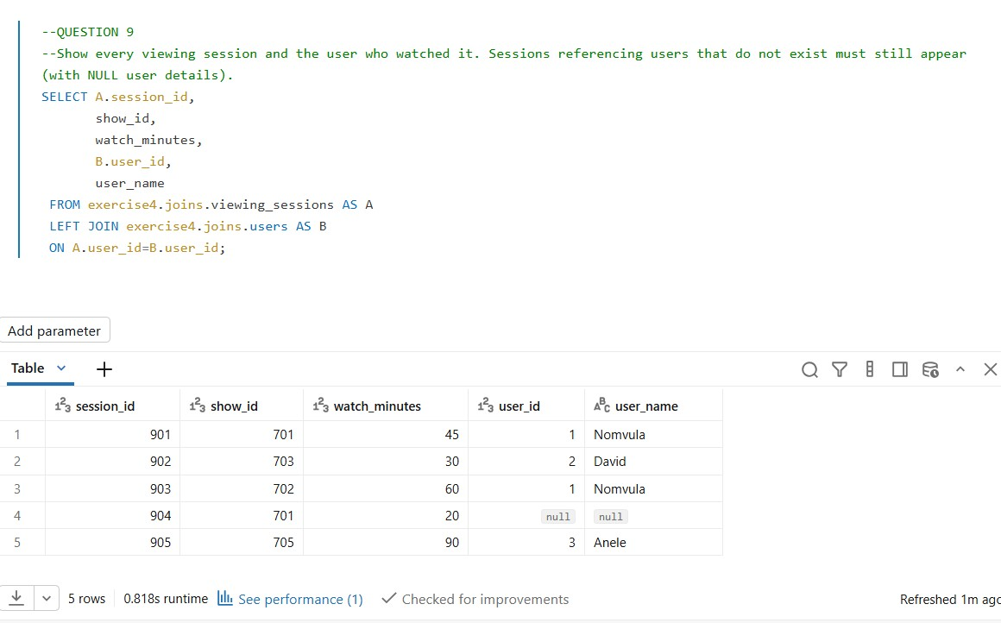

Show every user, the plan they are on (if any), and the monthly price. Users without a subscription must still appear.
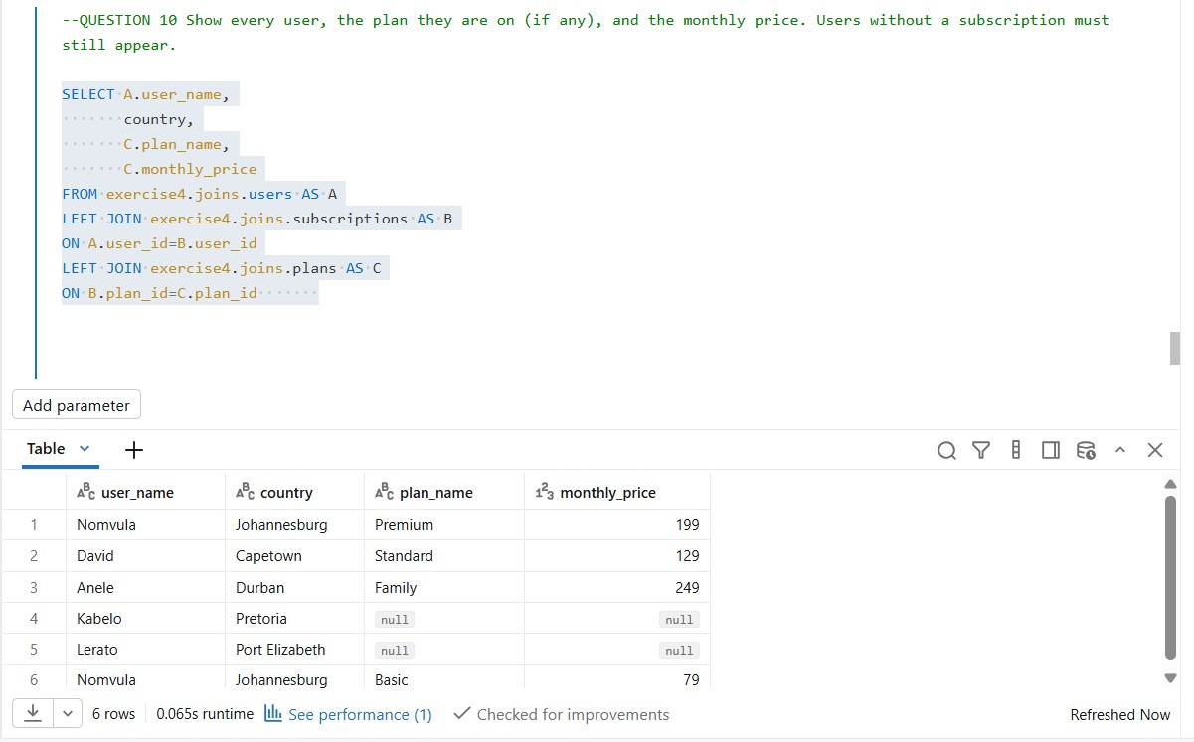

Show every user and every subscription, including users without subscriptions AND subscriptions referencing users that do not exist.
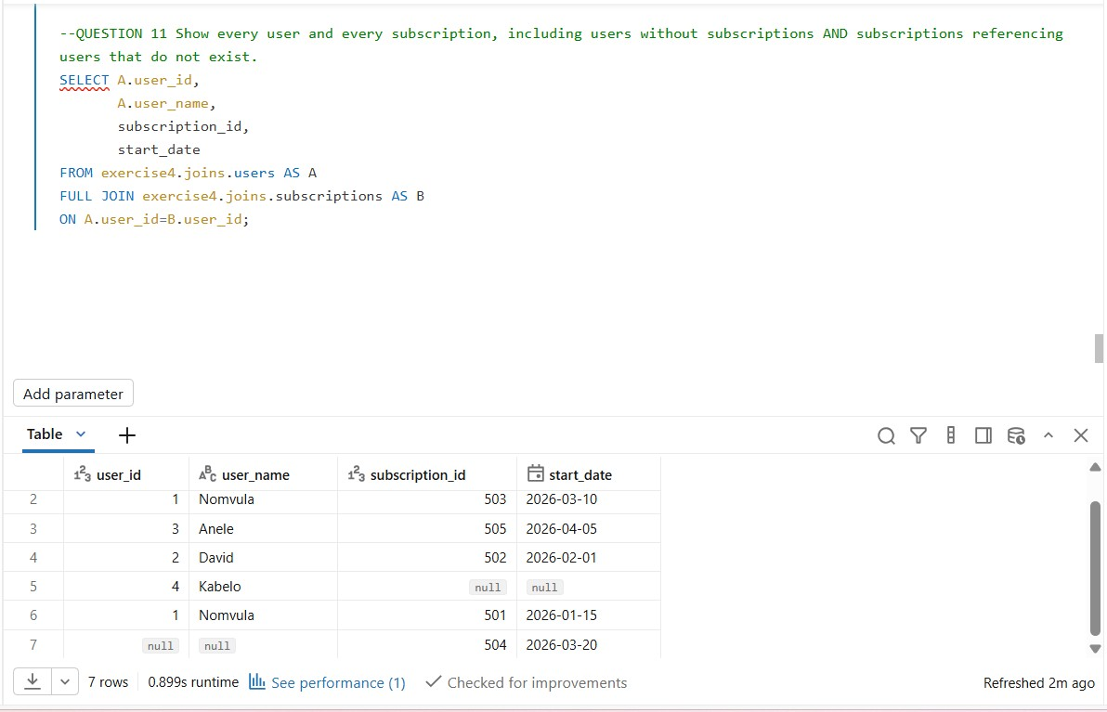

Show every plan and every subscription, including plans without subscribers AND any subscription referencing a plan that does not exist
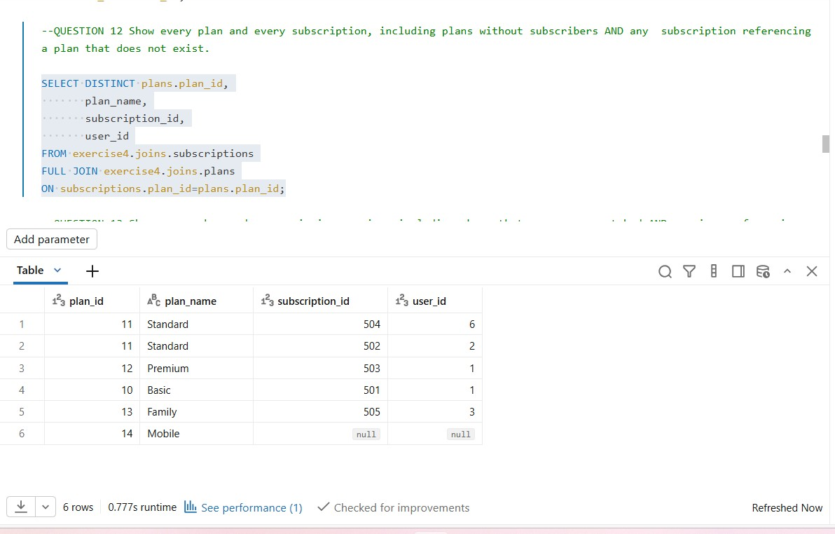

Show every show and every viewing session, including shows that
were never watched AND sessions referencing shows that do not exist.
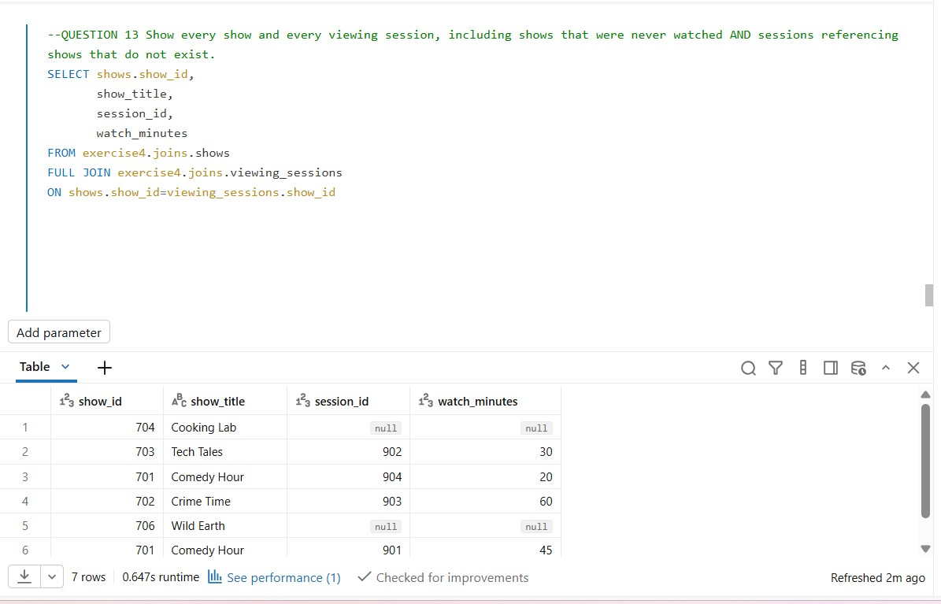

Show every user and every viewing session, including users with no sessions AND sessions referencing users who do not exist.
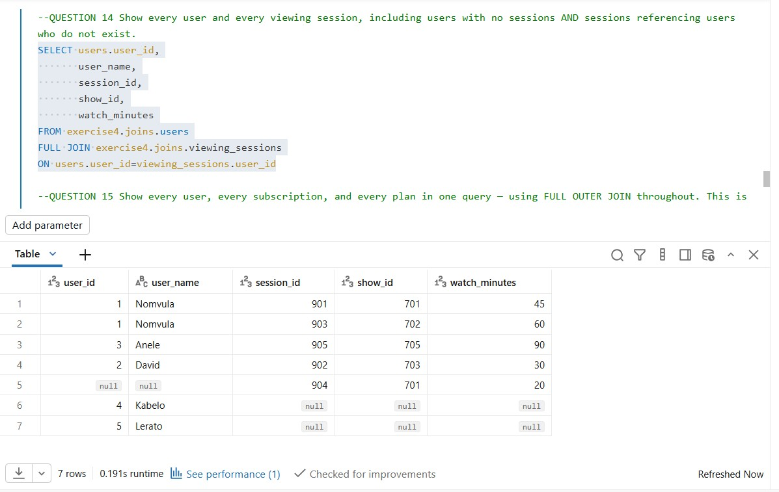

Question 15- Show every user, every subscription, and every plan in one query — using FULL OUTER JOIN throughout. This is the hardest question — get all gaps visible at once.
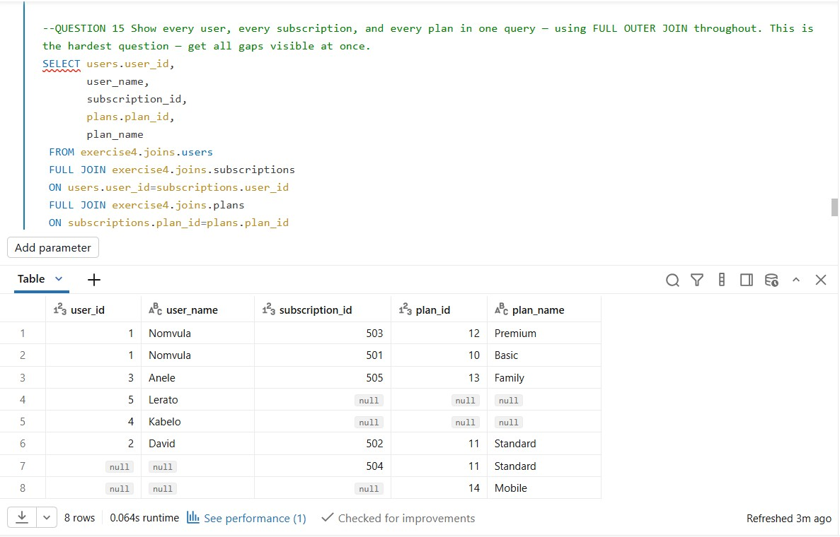

Bonus Challenge –

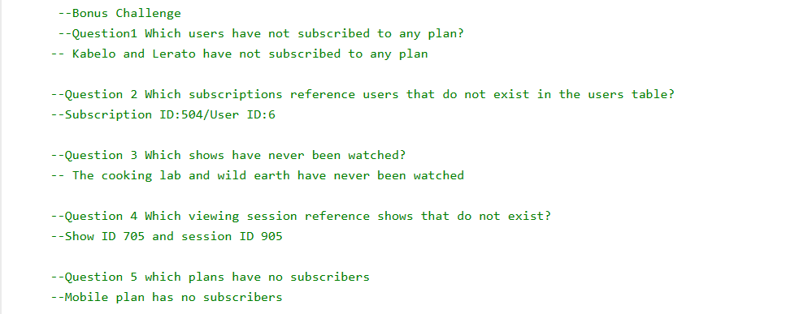
Question 1- Which users have not subscribed to any plan?
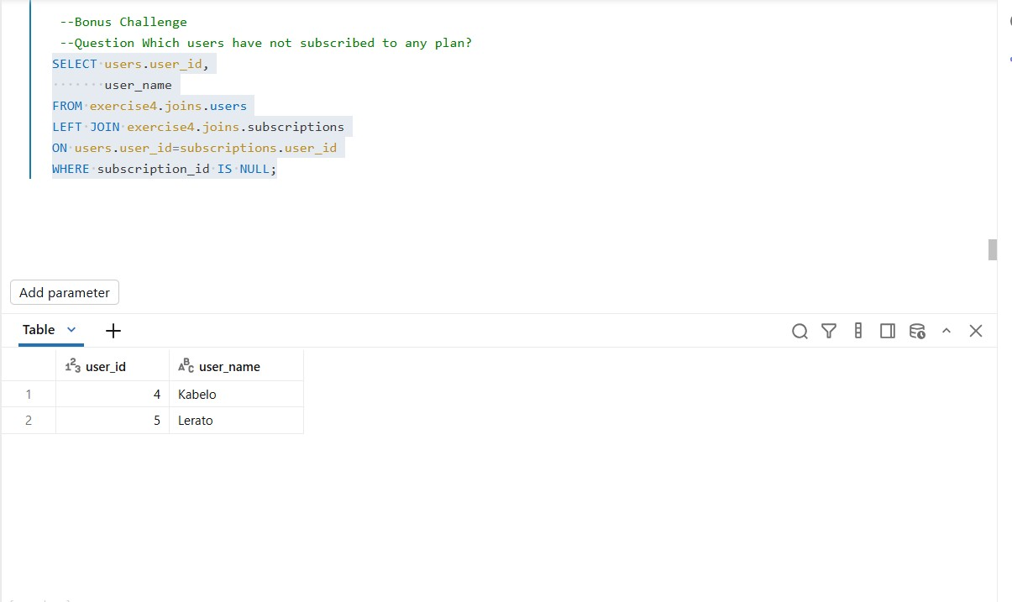

Which subscriptions reference users that do not exist in the users table?
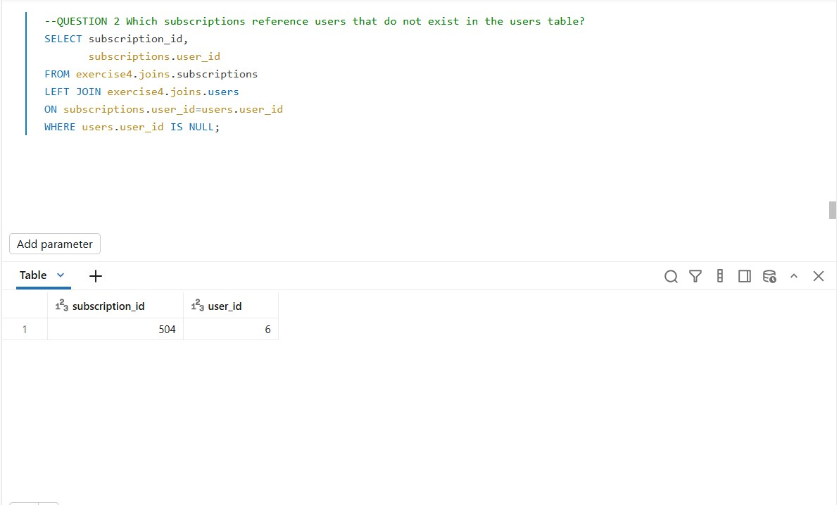

Which shows have never been watched?
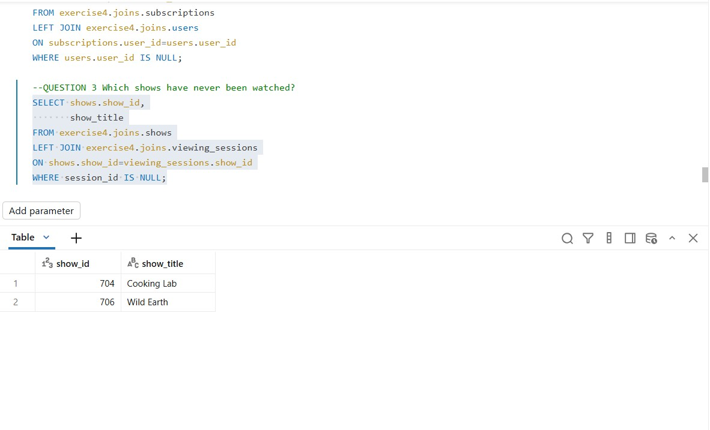

Which viewing sessions reference shows that do not exist?
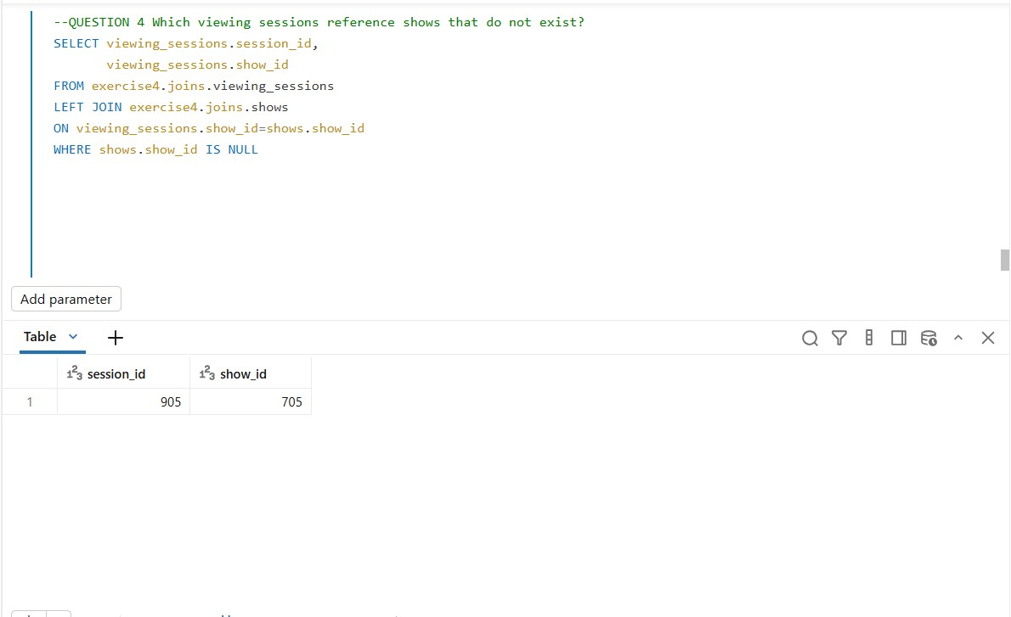

Which plans have no subscribers?
